# Register and setup Notifications on Council e-Tender system

To register as user on the Councils e-Tender system and setup notifications to be alerted when Tenders are issued, please click on the following link and then follow the instructions provided below

[e-Tender system](http://syd1-0061dsb.server-web.com/ETendering/LogIn.aspx?AspxAutoDetectCookieSupport=1)

Once you have registered on the system you can manage the notification categories by using the **My RFx Subscriptions** function as indicated below.

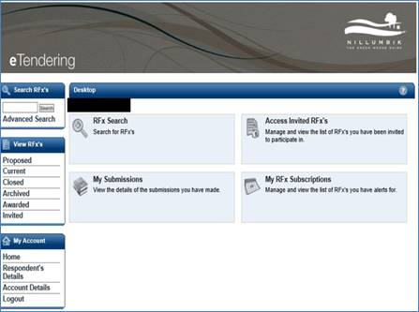

When you have selected that function, in the next screen you click on the add a new RFx subscription option

If you have previously registered you will also see any previous subscriptions (notifications) you have setup

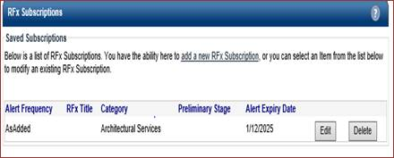

In the next screen you will be provided with drop down list options for Categories, Preliminary stages and can define the frequencies

